IAM Policies Assignment

Create a policies

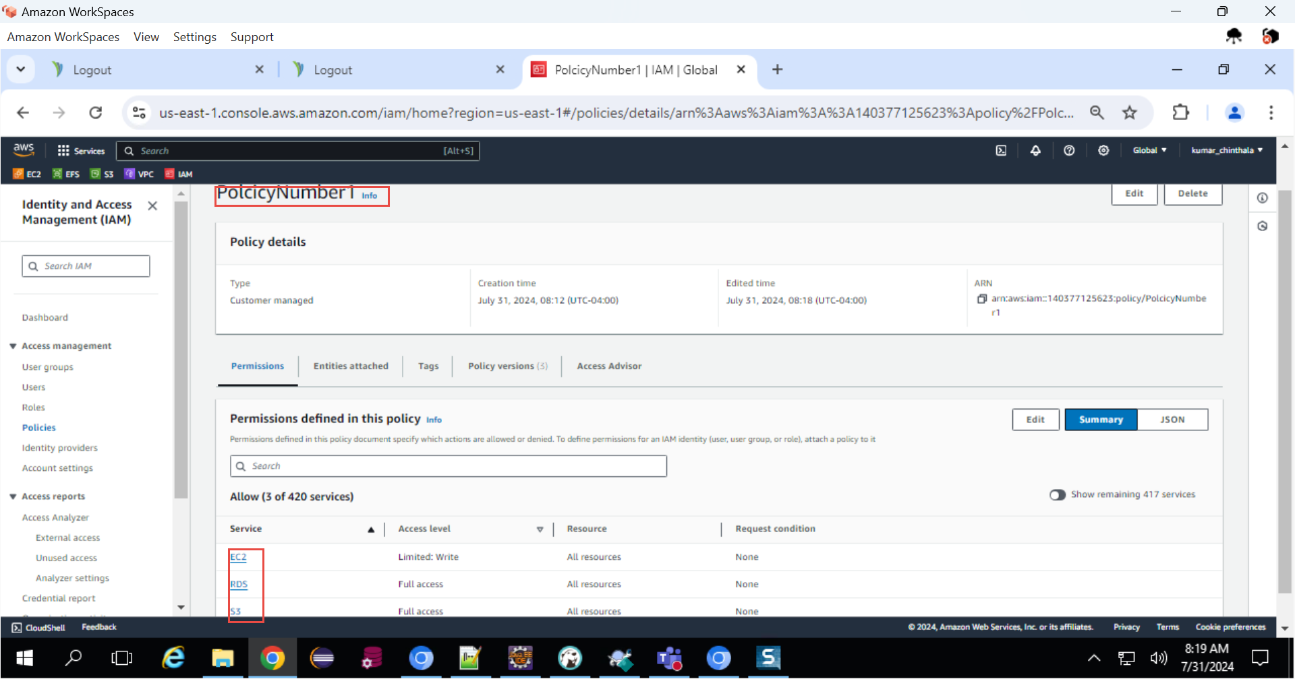

Attach Policies to groups

